Supermarket Management System (List)

* The program starts with giving two login options

(1)For admin

* The admin will login using username and password. Then a screen will show giving admin powers.

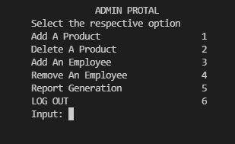

* The first option is to add a product to the market’s product stock.

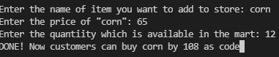

* The second option is delete a product from the market’s product stock.

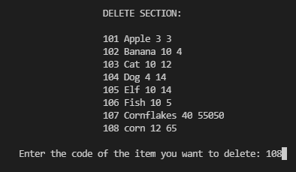 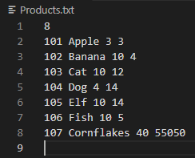

* The third option is to add an employee  
   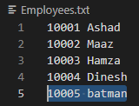

* The fourth option is to remove an employee

 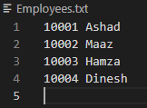

* The fifth option is report generation and a loading screen shows up while the program generates the sales report and shows it in a bar graph.

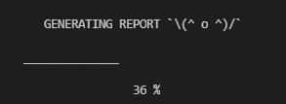 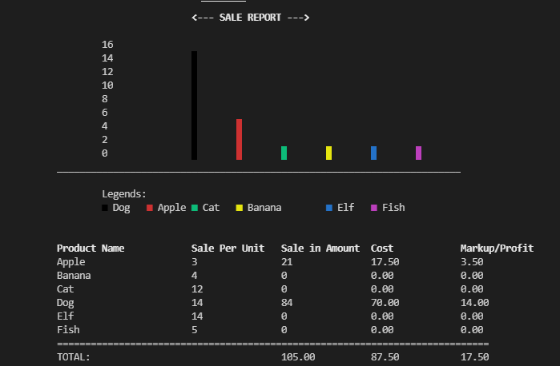

* The last option is the logout button which will again take the user to home screen.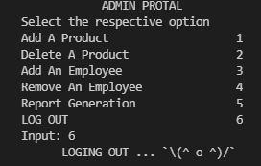

(2)For employee

* The employee’s cashier system opens up and asks the customer for membership.
* If the customer is already a member, he logs in using his unique ID and his registered name shows up while he is given customer options.
* If the customer is not a member, he is further given two options (Register an account, and input name with cell number or continue as an unregistered user). This customer is then also taken to the product menu.

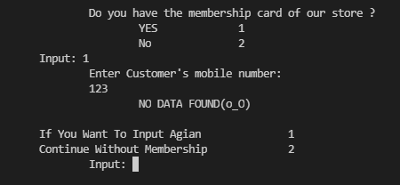

* The product menu is now open and the employee can input customer’s input code.

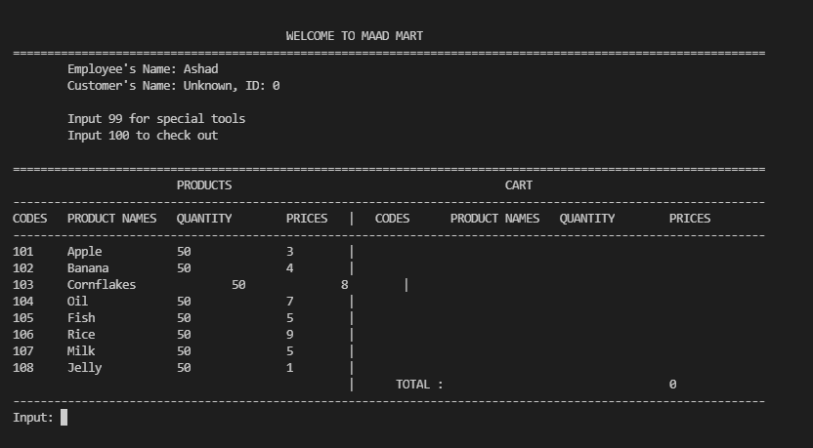

* The product menu displays item code, item name, available quantity and price per item.
* The employee inputs customer’s desired items adding them to cart.
* Invalid input is displayed if wrong code or quantity exceeding the available quantity is entered.
* Out of stock message is shown if a customer tries to add an item that has run out.
* Once the customer is completed with cart, he enters 0 for checkout or if he still wants to edit cart, he enters 99 for special tools.
* Tools have the option of delete which will remove an item from cart. The delete option asks for item code and quantity, and then removes it from cart.
* Another tool is the remove all option which will directly remove every item from the cart.
* The third tool is for going back to cart and continue shopping if the user wants to make any new changes before checkout.
* New customer enters after checkout.